MS SQL SERVER
Access Management for SSRS

Submitted to



BY



CIS, Wipro Limited

Document Details

Project Name | Innogy SE
Account | CIS
IT Component/Application Title | Access Management for SSRS
Current Version | 1.2
List of Contributors | Pradipkumar Kansara, Kiran Bhalekar, Ayushi Gautam, Sivakumar Goud, Pramod Patil
Customer Contact Information

Version History
(All revisions made to this document must be listed in chronological order. All revisions must be approved. Review and Approval can be done by an internal source or by the customer)
Version | Date of Revision | Description | Author | Reviewed By | Approved By
1.0 | 04-12-2017 | Initial Draft | Ayushi Gautam | Pradipkumar Kansara | Santosh Badiger
1.1 | 05-12-2017 | Document Completed | Ayushi Gautam | Pradipkumar Kansara | Santosh Badiger
1.2 | 1-12-2018 | Updated the content | Pramod Patil | Pradipkumar Kansara | Santosh Badiger

Document Distribution List
S.No | Name and Company | Purpose
1 | RWEIT-SQLDBA | This document is useful for the Reporting access management and Database Administration Services.
2

TABLE OF CONTENT
1. Purpose 1
2. Scope 1

3. Providing Reporting server Access in SSRS
3.1 Permissions 1
4. Providing Reporting server Access in SSRS

5. Providing Report Access in SSRS 17
6. Reference …………………………………………………………………………………………………………………17

Purpose

This document is prepared for the access management of Reporting services users and subscribers of SQL Server Database Administration Services.

Scope

This document is prepared for SQL Wipro sustenance team and provides the concepts, management and creation of Reporting user for the administration of the SQL Server database.

Providing Reporting server Access in SSRS

Permissions
To add user or Group to a system role:

- Go to Reporting services configuration manager, Login and connect.
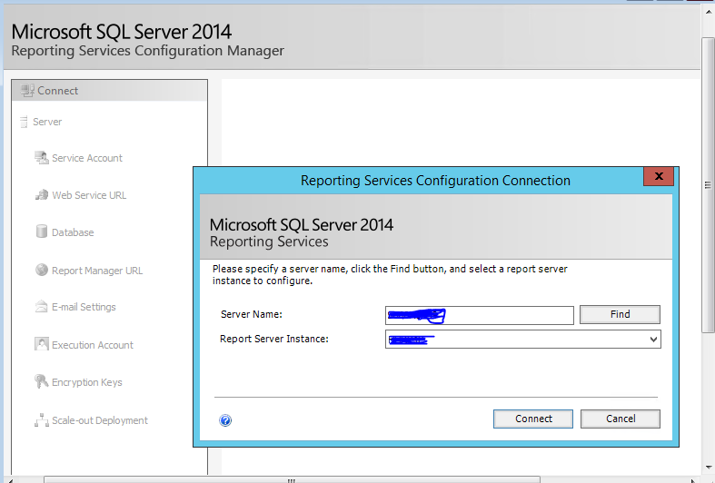
- Go to web Portal as a admin
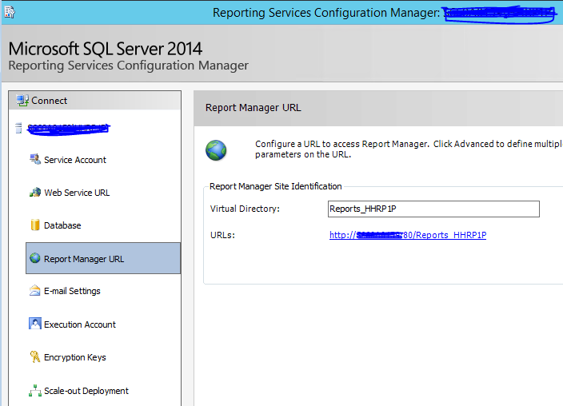
- Go to the Report Manager URL link
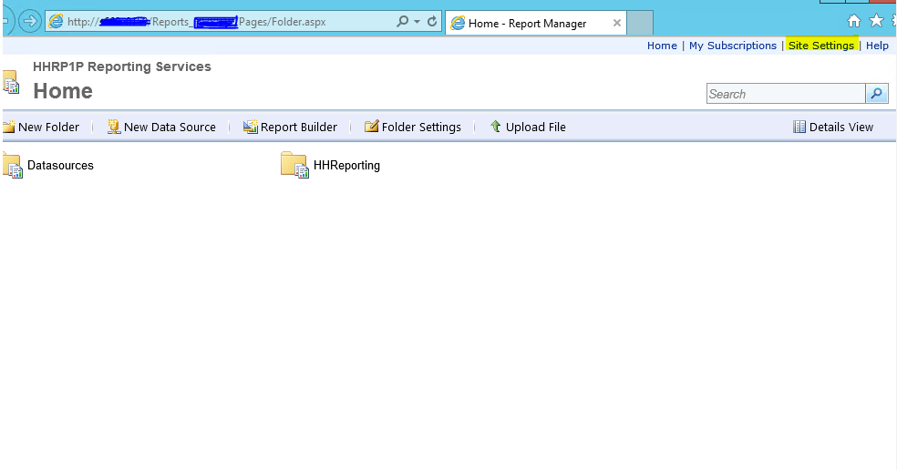
- select site settings
- select security
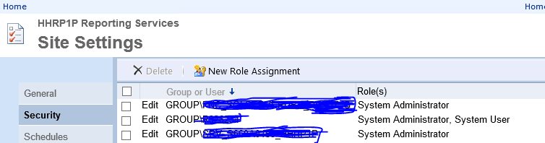

- Add group or users (New Role Assignment)
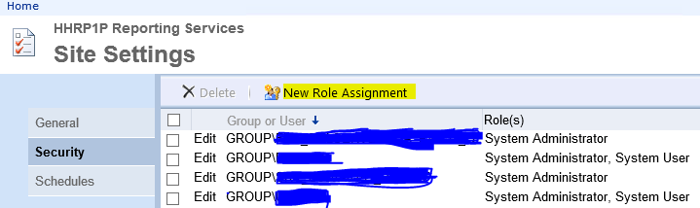
- New Role Assignment > Add Group or user name, check the role > ok
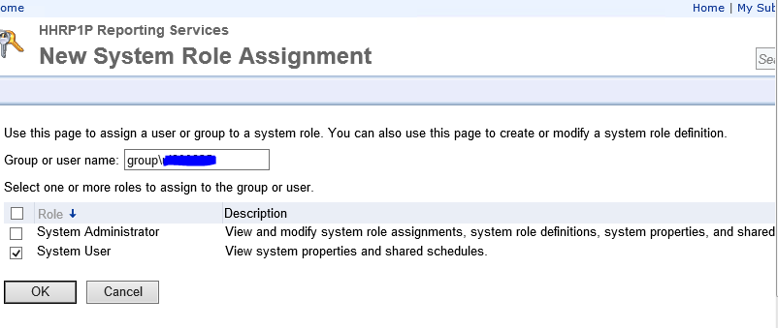
Note : If you are using forms authentication or custom security, specify the user or group account in the format that is correct for your deployment.
Roles are cumulative, so if you select both System Administrator and System User, a user or group will be able to perform the tasks in both roles.

Click OK

Providing Report Access in SSRS

- Go to Reporting services configuration manager, Login and connect.

- Go to Report Manager URL > Go to link

- Go to Report folder you need to provide access on
- Right click on report folder > Security

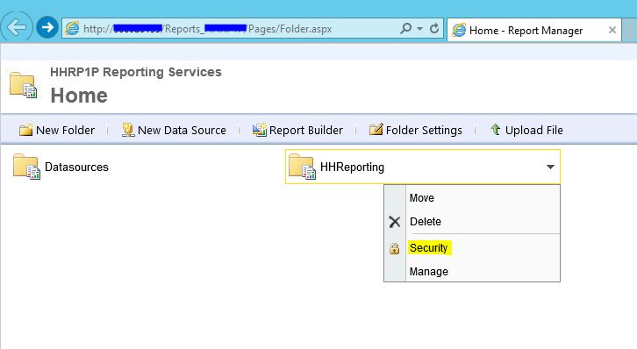

- New Role Assignment > add user/group

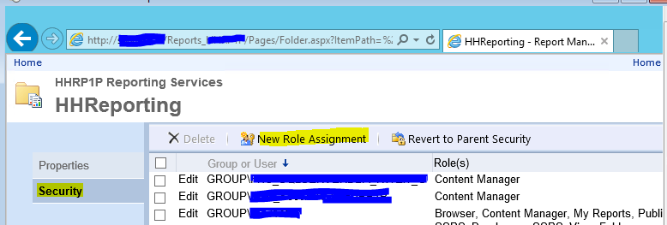

- Add user > Assign Role to the user > OK

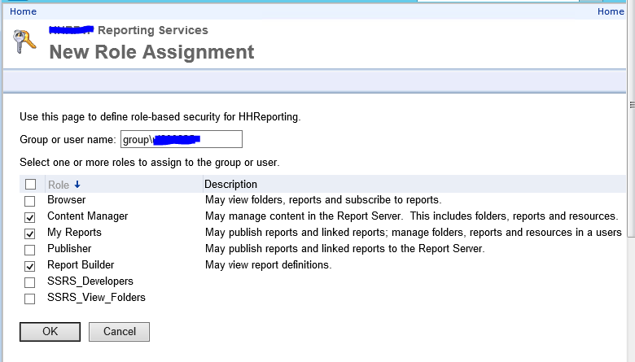

- User is added and have proper access on Reports > repeat the same if user needs access on other reports.
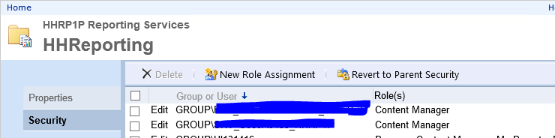

Reference

https://docs.microsoft.com/en-us/sql/reporting-services/security/grant-user-access-to-a-report-server

